Shabbos Stories for
Parshas beshalach 5782
Volume 13A, Issue 21 - 13 Shevat 5782/January 15, 2022
Printed L’illuy nishmas Nechama bas R’ Noach, a”h

For a free subscription, please forward your request to keren18@juno.com
Past stories can be found on the website ShabbosStories.com

The Inability to
Understand the Question
By Shmuel Butman
Director of the Lubavitch Youth Organization

The second day of the month of Shevat is the yahrzeit of Reb Zusya of Anipoli, a disciple of Reb Dov Ber of Mezritch (The Mezritcher Maggid), and colleague of Reb Shneur Zalman of Liadi, the first Chabad Rebbe.
The fact that illness and utter poverty were Reb Zusya's lot did not in the least effect his piety, humility, and love of G-d for which he was renowned.
A story is told of Reb Shmelke of Nikolsburg, who approached Reb Dov Ber of Mezritch and asked him how it was possible to follow the injunction of our Sages to "make a blessing upon hearing bad news just as one would make a blessing upon hearing good news." Reb Dov Ber told Reb Shmelke to go to Reb Zusya, and he would answer his question .
Reb Shmelke went to Reb Zusya, upon whom poverty and illness had left their physical marks. When
Reb Shmelke posed his question to him, Reb Zusya was surprised. He replied, "This question should have been brought to someone who has actually experienced unfortunate events, G-d forbid. Thank G-d, I have only had good things happen to me for my whole life."
The answer to Reb Shmelke's question was that someone should rejoice in his lot to the point that he is not even aware of harsh events. This was the hallmark of Reb Zusya's life.
Reb Shneur Zalman of Liadi held Reb Zusya in such high esteem that before printing his magnum opus, the Tanya, he sent a copy of it with a special messenger to Reb Zusya for his approbation.

Reprinted from the Parshat Va’eira 5757/1997 edition of L’Chaim, a publication of the LYO.
The Righteous Schlepper

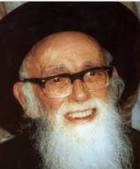
Reb Shlomo Zalman Auerbach, zt”l, was a gadol hador known not only for his encyclopedic knowledge and ability to posek halacha, but also for his sensitivity, generosity and compassion for the Jewish people, which followed in the footsteps of Moshe Rabbenu.
For many years, the local grocery store in Reb Shlomo Zalman’s neighborhood was run by a widow. To operate such a store consumed every ounce of the woman’s strength. Delivery vans would pull up at dawn and the truckers would deposit crates of milk and dairy products on the sidewalk. Later, the widow would drag them inside when she opened the store. One day, to her delight, she saw that the crates had been placed at the front entrance, considerably easing her workload.

The Widow’s Desire
To Thank the Drivers
This phenomenon recurred the following morning and continued day after day. One morning, the widow felt that she should thank the drivers personally, so she made a point of arriving at the store very early. However, to her amazement, when the vans appeared, the men deposited her delivery on the edge of the sidewalk as they had always done in the past. Perplexed, she stood hidden on the pavement wondering how the heavy crates had transported
themselves to her door, when suddenly the figure of Reb Shlomo Zalman Auerbach appeared, tefillin bag under his arm. One by one, he lifted the heavy crates, deposited them in front of the grocery store, and hurried off to shul. This is the kind of empathy and compassion we should strive to have.

Reprinted from Jack E. Rahmey’s Parashat Shemot 5782 email based on the teachings of Rabbi Amram Sananes.

Unknown Jewish Man Receives Full Jewish Burial
By Yoni Brown

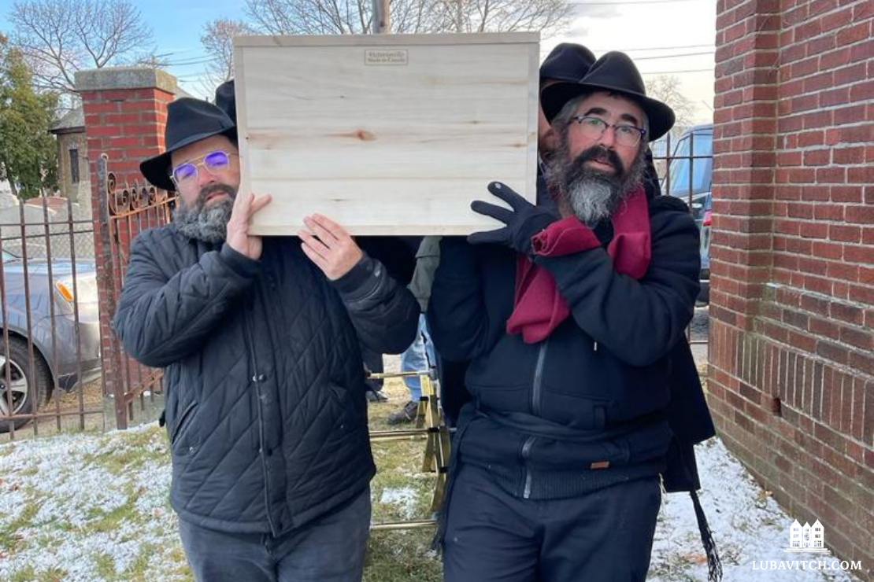

Every so often in the life of a Chabad emissary, an unusual little story comes along that leaves a poignant imprint.s
When a Jewish resident at a nursing home north of Boston passed away without any relatives, Amy Torf Feinberg of Torf Funeral Services placed a call to Rabbi Nechemia Schusterman. Did he want to organize a Jewish burial for the unknown man?

Answering the Call for an Incredible Mitzvah
Rabbi Schusterman immediately spread the word among his fellow Chabad shluchim, and Rabbi Mayshe Schwartz answered the call. “Whenever I hear about opportunities for an incredible mitzvah like this, I like to grab them,” he said. Between them they scraped together a minyan of exactly ten men, seven of whom were Chabad rabbis, to be able to recite Kaddish for the anonymous man.
“We only knew that he had been disabled, and had been in the care of various agencies since the fourth-grade,” Rabbi Schwartz said. “By the time he passed away at the age of ninety-six, he had spent almost a century in the care of others.”
The rabbis intended to try their best to give the anonymous man a proper Jewish burial; but not knowing his Hebrew name, they anticipated not being able to call him by his proper name in the appropriate prayers.

Realizing that Something Amazing Had Occurred
When we arrived at the designated burial site, we realized something amazing. It was a family plot with a shared headstone for a father named Hershel and a mother named Shaindel. Both had passed away nearly fifty years ago. But there was a third spot, which was open and marked, “Kalman ben Hershel” along with his date of birth.
It became clear that before his parents had passed away nearly half a century ago, they had taken the necessary steps to ensure that their disabled would receive a proper Jewish burial.
“Sure enough, all these years later we were able to call him by his name, Kalman ben Hershel,” said Rabbi Schwartz. “We were able to say Kaddish for him and give him a full Jewish burial.”

Reprinted from the December 12, 2021 dispatch of Lubavitch
International.

“Why Don’t You Pray?”
By Rabbi Dovid Goldwasser

A person should never be disheartened about the effectiveness of his prayers. The Talmud (Rosh Hashanah 18a) speaks of R’ Meir, who cited the feasibility of two individuals who were ill with the same sickness, yet one recovered and one did not. How could this happen? R’ Meir explained that one prayed with his whole heart and was answered, while the other did not pray with his whole heart and was not answered.

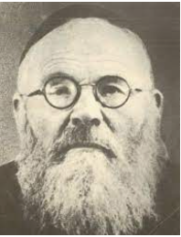
Rabbi Eliyahu Lopian

R’ Eliyahu Lopian asks: They knew their lives were in mortal danger. Wouldn’t they both devote themselves to sincere and fervent prayer, and ensure that there were no interruptions or intrusions in their thoughts?
We learn from here that praying with one’s whole heart encompasses more than deep kavanah (intent and concentration). It is an absolute belief and faith that one’s prayers can redeem the individual and save him from death or another adverse consequence.
We say every day in Ashrei, “Hashem is close to all who call upon Him, to all who call upon Him sincerely.” R’ Lopian offers a parable to explain this inconsistency.
On the date of his birthday, Czar Nikolai of Russia had the custom of opening the gates of his palace to the public. He allowed anyone to come in and make a request of him, which he would try to fulfill.

Only One Condition was Required
There was only one condition. The petitioner had to be able to speak Russian, and could not use the services of an interpreter to make his request. One could not have his appeal realized merely by being in the presence of the czar.
Similarly, Hashem is close to everyone who calls upon Him, but one must speak to Hashem with sincerity to achieve the desired results.
A malevolent and anti-Semitic person who worked in the home of one of the Jewish families in town stole money from a government official. He hid the empty purse in his employer’s home, and when it was found, the Jew
was brought to judgment and sentenced to death.

The Ksav Sofer was Shaken by the Terrible News
When the Ksav Sofer, the son of the Chasam Sofer, was informed about this turn of events, he was very shaken. He knew that the framed individual was innocent and was an upstanding member of the community. Many askanim tried to intervene, but they were unsuccessful. The Ksav Sofer then personally traveled to the city to intercede with the powers that be, but no one would listen and no one believed him.

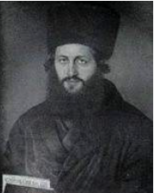
The Ksav Sofer and his father the Chasam Sofer

The Ksav Sofer returned to Pressburg, his hometown, the afternoon before the scheduled execution, discouraged by his lack of success. As he contemplated what else could be done to save the man, he fell asleep from sheer exhaustion.
As he slept, his father, the great Chasam Sofer appeared to him. He had promised that if there was ever a time when his son needed help, he would come to help him. The Chasam Sofer called out to his son: How is it possible that a Jew will be killed, leaving behind a wife and family, and you’re sleeping? Why are you not trying to help him?

“What Have I Neglected to Do?”
The Ksav Sofer became very agitated hearing his father’s reproach and began to cry: I have tried everything. What have I neglected to do?
The Chasam Sofer admonished him. “Why don’t you pray? At such a time you don’t lie down to sleep. You must shake up the Heavens with your prayer. You must bang on the gates of Heaven until Hashem has mercy. You don’t sleep now!”
The Ksav Sofer awoke, and immediately alerted all the members of the community – men, women and children – to gather in the main shul to pour out their hearts in prayer to Hashem. He pleaded with them to beseech Hashem, with unfaltering faith in His salvation, for an annulment of the death sentence. The assemblage heeded the words of the Ksav Sofer, and their cries pierced the Heavens.
When dawn arrived, the decree had been rescinded. Overnight, the police had received a tip from one of the thief’s partners. When they searched the house, they found the stolen money that had been hidden. The thief was taken to jail, and the Jew was freed.
All the inhabitants of the city witnessed firsthand the efficacy of sincere prayer that had the power to abolish a sealed decree.

Reprinted from the December 23, 2021 edition of The Jewish Press.

"What If There Is a G-d?"
By Yossy Gordon

When Rabbi Schneur Zalman of Liadi, known as the "Alter Rebbe" (1745-1812), began teaching the new path of Chabad Chasidism, he attracted many different types of individuals. Some sincere and some not so sincere. The latter were attracted to the novel intellectual discipline introduced by Rebbe, but not so interested in taking the difficult steps necessary to internalize the lessons for the sake of self-improvement.
One such young man was a businessman by the name of Shlomo Feigin. Though he was brilliant and enjoyed the intellectual challenge of the Alter Rebbe's teachings, sadly, his heart was not in it.

The Business Trip to Leipzig
It happened once that Shlomo needed to take a business trip to Leipzig. Prior to his departure, the Alter Rebbe summoned him. To Shlomo's surprise, the Alter Rebbe wanted to hear his travel itinerary. When the Rebbe heard that he was passing through the city of Karlin, he asked him to please pay a visit to his colleague, the saintly Rabbi Shlomo of Karlin, and convey his regards. Shlomo promised to fulfill the Rebbe's request.
Upon arrival at the home of Rabbi Shlomo of Karlin, Shlomo Feigin was shown to the waiting room, directly adjacent to Rabbi Shlomo's study. As he waited, he heard Rabbi Shlomo pacing in his study. Suddenly, the door to the study swung open and Rabbi Shlomo walked out and began to pace in the waiting room. Suddenly, Rabbi Shlomo loudly exclaimed: "Young man, young man, what will be if indeed there is a G-d in this world?"
Rabbi Shlomo then returned to his room. Shlomo Feigin, mesmerized by this strange scene, continued to wait.

Artwork by Sefira Ross

A few minutes went by. Rabbi Shlomo's pacing inside his office could again be heard in the waiting room. Again, the door swung open in a rush. Out came Rabbi Shlomo. Again, came the pacing and exclamation: "Young man, young man, what will be if indeed there is a G-d in this world?!" When this scene repeated itself a third time, Shlomo Feigin realized that this must be the reason for the Alter Rebbe's request that he visit Rabbi Shlomo of Karlin. He was supposed to witness this scene. He left and resumed his journey to Leipzig.

A Major Turn for the Worse
Sometime later, Shlomo Feigin's spiritual wellbeing took a major turn for the worse. He eventually succumbed to the promise of grandeur and power and forsook his faith. Highly gifted, he rapidly climbed the ladder of success till he was appointed to a high position in the Czar's government.
More years passed. The Alter Rebbe passed on to his eternal rest. The government decided to build a highway that would traverse the entire breadth of the land. To the chagrin of the Chassidic community, the proposed road's route ran directly through the place where the Alter Rebbe's holy remains had been laid to rest. The Chassidim decided to use whatever influence they had to change the route. Inquiries were made, and it turned out that the one in charge of the route was the apostate Jew Shlomo Feigin. The Chassidim were greatly concerned. Would a former colleague turned stranger, a man like Shlomo Feigin, be sympathetic to this cause?
The old chassid Reb Moshe Vilenker, who years earlier had spent time together with Shlomo in the Alter Rebbe's court, was asked to intervene. An appointment was secured. The aged Reb Moshe sat down with Shlomo and explained the situation. Without hesitation, Shlomo promised to reroute the road. But he had one request of Reb Moshe. Could they sit together that evening and schmooze like in times of old? Reb Moshe agreed.
During the course of their discussion, Shlomo confessed to something most personal: "You see all of my success, all of my wealth, all of my power? I cannot enjoy it. I constantly hear the words of Rabbi Shlomo of Karlin ringing in my head. 'Young man, young man, what will be if indeed there is a G-d in this world?!'"

Reprinted from the Parshat Va’era 5783 email of Chabad.Org Magazine.

Who Are You?
By Moshe S.

It's a simple enough question, but until recently, I haven't been able to answer it. "Who are you?" For years I was proud of who I was. I had no worries in the world. I was making great money, living a life of fun and fancy, and thought that nothing or no one could touch me.
For years I was a professional criminal. And then my world came crashing down. I was caught. I was found guilty. And I am now in the process of serving a twenty-year sentence in the Ramla prison in Israel. The day I entered the jail, I lost my identity. To the prison system, I was merely a number. I had a name, but no one knew it as I never used it. I had a reputation, but it was for what I had done. It no longer applied.
You can't be a thief when you aren't stealing. You can't be a drug dealer when you aren't dealing. But I only knew how to be a criminal. So behind bars, who was I? What defined me? I was a prisoner. And when you are a prisoner you have no definition. You have no status in the underworld and no status in the real world. You are nothing. Then I met Rabbi Fishel Jacobs, the chaplain at the Ramla prison.
And for the first time in my life, I began to learn the real answer. I am a Jew. I am a Jew who never really cared that he was a Jew. I am a Jew who was raised, like most Israelis, with the basic traditions, but with little care or understanding as to what any of it meant.

Rabbi Fishel Jacobs on the cover of Mishpacha Magazine.

Like many other Sephardi immigrants, my grandparents were quite religious, but it was never passed down. What was passed down was the poverty, the illiteracy, and the hopelessness that many immigrant families have experienced. What was passed down was the need to survive and thrive at any cost.
And that was exactly what I did. I was a great criminal. I knew how to lie, cheat, steal, and essentially get whatever I wanted whenever I wanted. I had no qualms about my actions. I felt I was just helping make the world a little more balanced. It wasn't my fault that I was raised with barely enough food to eat. I couldn't change what I was given, but I could change what I would get.

Learning the Wrong Things
at a Very Young Age
And so, from a very young age, I learned what was profitable. Drugs and weapons were profitable. What I didn't realize was that they were also deadly. I watched my friends die. Some physically, others emotionally or mentally. I watched them reach a point where nothing mattered. A point that I never wanted to reach and feared that I would.
Few believe this, but I think I really wanted to get caught. Call it pop-psychology, but I think my getting caught was my cry for help. I knew something needed to change, but for the first time, I didn't know how to do it. I only knew how to do wrong. No one had ever taught me what was right. Getting caught and thrown in jail was a real blessing — and not even so much one in disguise. I really think it saved my life. But it was Rabbi Jacobs who saved my soul. He introduced me to who I was, to who I am, and to who I want to be.
Fishel is the chaplain at my prison. He has many jobs here, from ensuring that our kosher food is always fresh and sanitary, to making sure the sukkah is set up properly, to providing us with classes and learning. At first, when I watched him make his rounds, I thought that if he knew what was good for him, he'd better stay away from me. Upon mentioning this to a fellow inmate, I was informed that he was a black-belt in karate and if I was smart, I may want to stay away from him.

So, I quickly realized that fighting this Orthodox rabbi would be a good way not only to end up in isolation but would be a fight I would sorely lose. I figured I would rely on the age-old idea that if you can't beat them, join them. He couldn't be that bad if the other inmates liked him so much.
The first time he entered my cell, I realized that this meeting was going to be very different from what I've become accustomed to. Here was someone who didn't care about my criminal past, wasn't impressed with my rap record, and only wanted to focus on what's inside me.

His Job Was to Help Other Jews Discover What It Means to be Jewish
No one had ever taken the time to ask or care what was going on in there. He did. He took one good look at me, and his eyes entered a place so deep within-a place I didn't even know existed. He explained to me that he is a Chabad Lubavitch Chassid, and his job was to help Jews discover what it means to be Jewish. That was it. Simple as could be. Here was a man who had won national championships in karate, a scholar with published books on Jewish law, a PhD equivalent granted by the Rabbinate of Israel and an army general, and his main goal in life was to teach me that I was a Jew.
Here was someone who embodied that exact opposite of everything I knew. I knew people who were nothing but pretended to be something. Here was someone who was a success in so many ways, yet to him it meant nothing. All that mattered was helping others. And working with prisoners is no easy task.

Let's be honest here. We are the garbage of the world. We are the people you hate, and rightly so. There is a reason we are behind bars. We did something that landed us here. With few exceptions, we deserve to be where we are. So, what kind of person, with ability, intelligence, and options, chooses to work with us? This was the first question I asked Fishel when he entered my cell.

An Answer that Blew Me Away
And his answer blew me away. He told me that the same question was once asked of his Rebbe, the Lubavitcher Rebbe, in regards to how he didn't tire standing for hours, handing out dollars to hundreds upon hundreds of people. The Rebbe answered that when you count diamonds you don't get tired. So Fishel said that even when those diamonds end up in a pile of mud when you know there are diamonds, you'll stick your hand right in and pull them out. The mud may cover the diamond, but it can't penetrate it or diminish its beauty and value. and the mud will wash off. I was a diamond. Most certainly covered in mud, if not worse, but a diamond nonetheless. Who would have thought that being imprisoned would be the greatest thing that could have happened to me? It wasn't until I came to prison that I learned who I was. Until then I thought I knew, but I had no idea. Now, even though I am physically behind bars, I am finally free within. And though this is not a place where I want to stay, I am using every minute of my time here as an opportunity. An opportunity for growth, repentance and change.

No Longer in Prison, but in a Yeshiva for Ex-Criminals
I have begun to view my sentence as a Yeshiva for ex-criminals. I have a lot of time here to study Torah, and I attend a Tanya class and Halachah class with Fishel every day. I keep Shabbat, eat kosher food, and do mitzvot whenever I can. Funny enough, because I was so well known on the streets, other inmates are willing to attend the classes and learn because of me. Go figure.
I wait for the day of my release. I await the day when I can give back to society and try and make up for the damage I did. I yearn for the day when I can marry a wonderful woman and bring beautiful children into this world. And when I do leave these prison walls, I will know what to answer when asked who I am. I am Moshe. I am a diamond. I am a Jew.

Reprinted from the Parshat Vaera 5782 email of Lamplighter.

What Makes You Great?
By Rabbi Eliezer Abish

One time, Rav Moshe Feinstein was at home, and his grandson was sitting with him. “Zaidy,” he asked, “how is it that you are not a baal gaava (arrogant)? After all, the whole world comes to you with their questions. Whatever the difficulty is, you are the address. How can you not become full of yourself?”

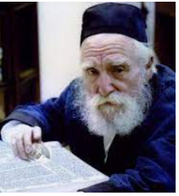

Rav Moshe replied with the following. There is a well-known Gemara (Bava Basra 11b) which speaks about Yosef ben Yehoshua who slipped into a coma. As others gathered around his bed and stood davening, he came out of the coma, whereupon his father asked, “What did you see up there in Heaven?”
“I saw an upside-down world,” he replied. “Those who over here, in this world, are high up, up there, are at the bottom. And those down here who are not held with great esteem, up there, are held with great esteem.”
“You saw a clear world,” his father replied.

How Do We Understand This?
What does this mean? Are we all making such mistakes with our judgment of people in this world? Rav Moshe explained that here, in this earth, we are judged based upon our accomplishments; in Heaven, however, we are judged based upon our potential. While, down here, someone can learn for ten hours straight and he has a lot of knowledge, who knows what his potential is. If he learns for ten hours, he may have amassed a lot of knowledge, but his potential may be twelve hours, and that is what he is judged for in Heaven.
But what about someone down here who learns for fifteen minutes straight, and that is his potential? When he comes to Heaven, he is held in great esteem.
“It is true that I have a lot of Torah knowledge,” responded Rav Moshe. “But you know what keeps me up at night? Maybe there is more. Maybe I can do more. And even though I do a lot, maybe there is more I can do. That is what keeps me humble.”

Anyone Can Be As
Great as Moshe?
In fact, when the Rambam (Hilchos Teshuva 5:20) writes that anyone can be as great as Moshe [Rabbeinu], that is what the Rambam is referring to. Anyone can be as great as Moshe as long as you fulfill your potential.
And then Rav Moshe said something very interesting. There was once a fellow who became a baal teshuva as a teenager. His father supported him, and he was very happy to see him learn and grow. After coming home from school, the boy would take out a big Gemara and start learning.

Curious About What
His Son was Studying
One day, after a few weeks of watching this, the father said, “What are you studying so much?” “I am studying the Talmud,” the boy replied. After a few weeks of seeing how engrossed he was, the father decided to find out for himself what his son was dedicating time to.
“Why don’t you teach me what you are learning? Show me what you are doing…” “Okay,” replied the son, “but it’s not easy.” Every day the boy would come home from yeshiva, and teach his father Gemara for twenty minutes. This went on night after night after night. After a few months, they turned the page and started to learn the second side, Amud Beis.
They got towards the end, and eventually got to the end, at which point the father said, “Isn’t there some kind of celebration you make when you finish learning something?”

The Concept of a Siyum
“Yes, there is,” his son said. “It’s called a siyum, but a siyum is made on the whole mesechta.”
“Oh,” mumbled the father. “We spent so much time on this; I thought we would also be able to make a siyum.”
The son didn’t know what to do. He decided to approach Rav Moshe and explain the situation to him. His father wanted to make a siyum. Is it appropriate? “Of course, it is appropriate,” said Rav Moshe. “To hear such an incredible story, you should make a siyum. But please, invite me to that siyum.”
The boy was thrilled. A few weeks later, they were finished, and they made a siyum, and invited Rav Moshe. Rav Moshe came himself and spoke at the siyum, saying how proud he felt to see what was accomplished. The father was very proud of himself as well, and went to sleep that night with the wonderful feeling of accomplishment.

That was the last night the father went to sleep… he never woke up. The next day, Rav Moshe spoke at the funeral. “There are those who acquire their Olam Habah in one hour. This father acquired his Olam Habah with one blatt of Gemara. He worked so hard and fulfilled his potential. His potential was to learn one blatt, and he reached one blatt. Yeish Koneh Olamo b’Daf Echad.”
This, explained Rav Moshe, is the meaning in the above Rashi. Moshe and Aharon were both equal because they both reached their potential. And anyone who reaches his potential can be as great as Moshe Rabbeinu.

Reprinted from Parshas Va’eira 5782 email of TorahAnyTime as compiled and edited by Elan Perchik.

The Stubborn Old Sinner
By Mordechai Levin

Beginning in the late 1700’s, European Orthodox Jews were terribly challenged by the pull of the Haskala Movement (Jewish Enlightenment). Various intellectuals attempted to attract yeshiva students towards secular learning, and lead them away from traditional Torah study.
A leader of the movement, known as Adam HaCohen, tried to convince the Chofetz Chaim, zt”l, when he was just 15 years old and learning in Vilna to join the “Maskilim”. The Chofetz Chaim ran away to Eisheshok to escape the intellectual attacks of Adam HaCohen. When the Chofetz Chaim was older, he related a story that happened with this Adam and his good friend Aron Ginsburg.
The two of them, as they reached old age, made a pact and solemn vow that the first to die would appear to the other within a year after his death to ascertain if there was truth to the Orthodox belief in the soul surviving physical death, and that there was a World to Come. Aron died first.
A few months later, Adam was walking on the road past the cemetery. He looked up and saw his friend Aron standing on his tombstone, staring at him with a piercing glare, and Aron’s face was black, like the burnt bottom of a pot. Adam immediately fainted from shock and terror.
The Chofetz Chaim asked, “Do you think Adam did teshuva”? He was picked up and carried home. When he came to, he explained away the horrible “vision” that he had experienced as occurring due to his sadness over the death of his friend.
“People like that don’t react to Hashem’s signals and they don’t repent, even if they are standing at the entrance to Gihenom,” he sadly concluded.

Reprinted from the Parshas Va’era 5782 email of Torah Sweets Weekly edited by Reb Mendel Berlin.

